**Lesson summary**

To recap, lifecycle events are special methods that React provides that allow us to hook into different points in a component's life to run some code. Now there are a number of different lifecycle events and they will run at different points, but we can break them down into three distinct categories:

**Adding to the DOM**

These lifecycle events are called when a component is being added to the DOM:

* constructor()
* componentWillMount()
* render()
* componentDidMount()

**Re-rendering**

These lifecycle events are called when a component is re-rendered to the DOM

* componentWillReceiveProps()
* shouldComponentUpdate()
* componentWillUpdate()
* render()
* componentDidUpdate()

**Removing from the DOM**

This lifecycle event is called when a component is being removed from the DOM

* componentWillUnmount()

It's easier to tell where all of these fit together with the following graphic:

**[[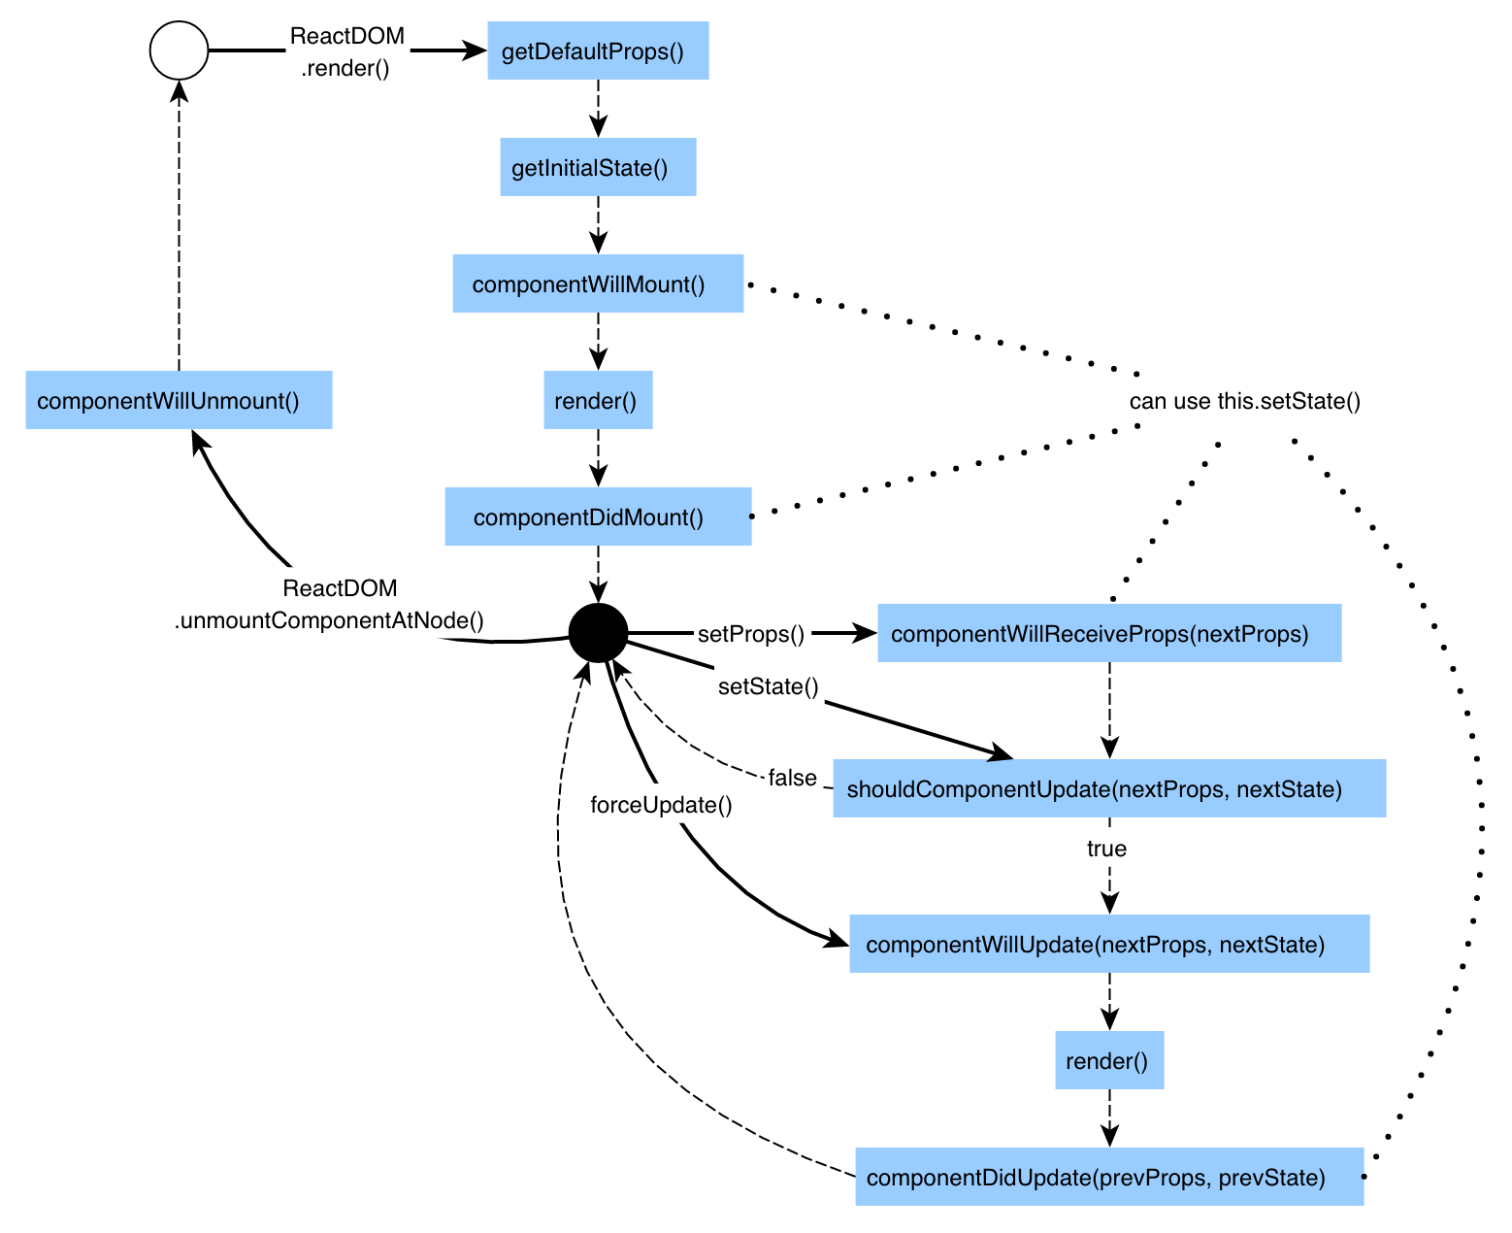](https://classroom.udacity.com/nanodegrees/nd001/parts/f4471fff-fffb-4281-8c09-2478625c9597/modules/82766b2b-1870-4904-aa90-8ccbe63928c5/lessons/ceb0042f-3e00-4bd2-a1d4-7746ec9c138a/concepts/3612061d-6488-454c-9818-cc6bcba02f5e)](https://classroom.udacity.com/nanodegrees/nd001/parts/f4471fff-fffb-4281-8c09-2478625c9597/modules/82766b2b-1870-4904-aa90-8ccbe63928c5/lessons/ceb0042f-3e00-4bd2-a1d4-7746ec9c138a/concepts/3612061d-6488-454c-9818-cc6bcba02f5e)**

***[The React Lifecycle Events listed out where they fall in a component's life.](https://classroom.udacity.com/nanodegrees/nd001/parts/f4471fff-fffb-4281-8c09-2478625c9597/modules/82766b2b-1870-4904-aa90-8ccbe63928c5/lessons/ceb0042f-3e00-4bd2-a1d4-7746ec9c138a/concepts/3612061d-6488-454c-9818-cc6bcba02f5e)***

Starting from the top left of the image, everything starts when ReactDOM renders the component.

As you can see, between the list and this graphic there are a number of different lifecycle events. However, the most commonly used ones are componentDidMount(), componentWillMount(), componentWillUnmount(), and componentWillReceiveProps().

**Further Research**

* [**componentWillMount()**](https://facebook.github.io/react/docs/react-component.html#componentwillmount) from the React Docs
* [**componentDidMount()**](https://facebook.github.io/react/docs/react-component.html#componentdidmount) from the React Docs
* [**componentWillUnmount()**](https://facebook.github.io/react/docs/react-component.html#componentwillunmount) from the React Docs
* [**componentWillReceiveProps()**](https://facebook.github.io/react/docs/react-component.html#componentwillreceiveprops) from the React Docs
* [**Component Lifecycles**](https://facebook.github.io/react/docs/react-component.html#the-component-lifecycle) from the React Docs